LABORATORY # 8

Amplification of a Signal at Using JFETs

Introduction:
So far we have looked at the bipolar type transistor amplifier and especially the common collector / common emitter amplifier, but small signal amplifiers can also be made using Field Effect Transistors or FET’s for short. These devices have the advantage over bipolar transistors of having extremely high input impedance along with a low noise output making them ideal for use in amplifier circuits that have very small or weak input signals.
The JFET is more expensive than conventional bipolar transistors but offers superior overall performance. Unlike bipolar transistors, current can flow through the drain and source in any direction equally. Often the drain and source can be reversed in a circuit with almost no effect on circuit operation.
Let starts with circuit as shown in Fig. 10.1. This circuit was prepared and verified in this lab EB225 to amplify a weak signal (30 – 80mV) at Low to High frequency range as given in Table 10.1.
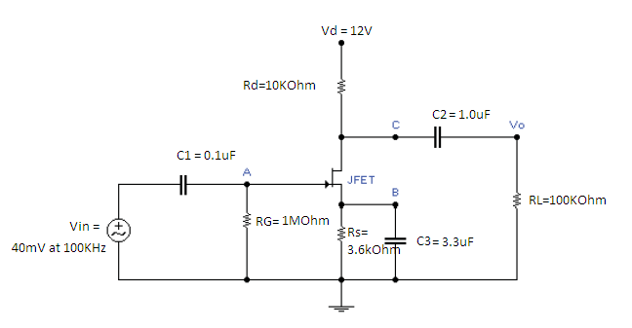
Figure 10.1

Table 8.1
Frequency | Vout | Voltage Gain
10 | 0.072 | 1.8
30 | 0.136 | 3.4
60 | 0.209 | 5.2
100 | 0.253 | 6.3
200 | 0.282 | 7.1
500 | 0.292 | 7.3
1 KHz | 0.294 | 7.4
2 kHz | 0.294 | 7.4
5 KHz | 0.294 | 7.4
10 KHz | 0.294 | 7.4
15 KHz | 0.294 | 7.4
20 KHz | 0.294 | 7.4
50 KHz | 0.294 | 7.4
75 KHz | 0.294 | 7.4
100 KHz | 0.294 | 7.4
150 KHz | 0.294 | 7.4
200 KHz | 0.294 | 7.4
500 KHz | 0.294 | 7.4
750 KHz | 0.294 | 7.4
1 MHz | 0.294 | 7.4
1.5 MHz | 0.294 | 7.4
2 MHz | 0.294 | 7.4
5 MHz | 0.289 | 7.2
10 MHz | 0.268 | 6.7
20 MHz | 0.218 | 5.5
25 MHz | 0.194 | 4.9
30 MHz | 0.173 | 4.3
40 MHz | 0.140 | 3.5
50 MHz | 0.116 | 2.9

Procedure:
- Build the circuit as shown in Figure 10.1 in Multisim and amplify a signal with Vin=40mV at given frequency range using JFET (2N5486).
- Build the circuit as shown in Figure 10.1 in Lab and amplify a signal with Vin=40mV at given frequency range using JFET 2N5486.
- Based on Table 10.1 results, plot voltage gain as a function of frequency. Calculate the approximate band width with F_{low} and F_{high}.
- Attach input and output waveforms for both Multisim and experimental results. (Try to capture at least three running simulations).
- Discuss the results in conclusion section.

